University of Stirling
Division of Management, Work and Organisation
MANU9DA: Individual Simul8 Assignment (Autumn 2025)
UK Insurance Company Service Modernisation Initiative
Technical Report
Student Name: [Dylan Gordon Brindle]
Student ID: [3361786]
Word Count (excluding tables/figures): [e.g., 1,606]
Submission Date: 7th December 2025
Module Coordinator: [Naja Mohd Yusof]

Executive Summary
This report uses Simul8 to assess the performance of the CEO’s proposed fixed-hours and 24-hour models, and introduces an improved model to prevent bottlenecks. Each model was simulated over 7 days with 22,500 customers. KPIs were used to assess each model's completion rates, performance, and wait times. The 24-hour model outperforms the fixed-hours model, despite persistent bottlenecks. The improved model disperses customer traffic so that no queues are congested. There are recommendations to reinstate the email system to prevent excess customer pressure.

Tables of Contents
Executive Summary .................................................... 2
Introduction ................................................................ 3
Methodology .............................................................. 3
Description of Models .............................................. 3
Validation Against Historical Data ....................... 4
KPI Table Interpretation ........................................... 4
Analysis of the CEO’s Vision .................................. 5
Recommendations to Management .................... 5
Suggestions for Further Analysis ........................... 6
Conclusion ................................................................. 6
Bibliography .............................................................. 7
Appendix ...................................................................... 7

Introduction
This report conducts a simulation-driven analysis of the feasibility of the CEO’s conceptual models, using Simul8 to assess the performance of the 24-hour and fixed-hours models. Each model was simulated over a 1-week period — scaled to the demand of 22500 customers — mirroring the 4-week operational target of 90000. The analysis will cover three distinct models, two proposed by the CEO and a third model iteration involving a design enhancement to prevent bottlenecks. KPIs were used to evaluate performance metrics on queue times, customer service completions and service times, to assess each model's optimisation strategies. The findings consider the system constraints of limited chatbots, employees, and active webforms that affect these model iterations and how these proposed designs adjust workflows to alleviate workflow congestion.

Methodology
Simul8 is used to improve the logic of Harbour’s original model, enabling KPI comparisons, analysing wait times across all channels to identify resource-allocation deficiencies, and highlighting realistic solutions for pragmatic systems. Simulation packages require specific input information, such as “arrival times, service times, and process flow” (Wisniewski, 2020, p. 503). Using a discrete-event simulation, each model used a 7-day workweek with 22,500 customers, equivalent to the target of 90,000 customers over the 4-week period.
The CEO has proposed two models: one based on the current 08:00 to 18:00 operations, and another on a 24-hour system with three 8-hour shifts, each staffed by two trained employees. A third model was developed to improve collective channel productivity, addressing the congestion caused by uneven demand that was disproportionately pressuring specific channels. Subsequently, models were simulated 100 times to ensure statistical significance given the stochastic nature of the simulation. C-SAT scores were applied to assess whether customer service channels resolved customer queries using the metrics in Appendix 4.1
. KPIs such as average and standard deviation of queue times, the number of customer queries resolved, and capitalisation of resources were used to assess the efficiency of the models

Description of Models 250 words
Model 1 (Appendix 1.2) is based on Harbour’s current operations, using a structured shift from 08:00 to 18:00 in which customer queries are first answered by the chatbot centre, then by a web form, and finally by the call distributor. This branches out 16.73% of customers to home insurance, 32.91% to vehicle insurance, 41.92% to travel insurance, and 8.44% to life insurance, based on historical patterns of customer service calls in May, which aims to improve the model's service time efficiency (Appendix 4.2).
Model 2 (Appendix 1.3) is the CEO’s premise for proposing a 24-hour system, allowing operations to run longer and preventing bottlenecks when customers use the chatbot service. For unresolved customer enquiries, webforms are used to reduce consumer pressure on the call centre, and customer satisfaction scores of 6 or above are used to determine whether the call resolved the customer's problem, with 51.67% resolved and 49.33% unresolved.
My model (Appendix 1.1) is inspired by the CEO’s 24-hour system, as it reduces customer traffic the following day. Unlike the CEO's streamlined system of operations, this model uses an organiser to synchronise customer service across all channels, which has been effective at preventing bottlenecks. The model integrates an email service using customer satisfaction scores from Harbour’s dataset to determine whether the call was effective at resolving a consumer's query based on historical data in May 2025, with a score of 1-5 indicating the issue is unresolved (34.35%) and 6-10 indicating it is resolved (65.65%) (Appendix 4.3).

Validation Against Historical Data
A key limitation of the simulations arises from the database itself, as no customer's name appeared more than once among 32,941 submissions, which is probabilistically implausible. This suggests that customers who moved to another service were not tracked again, thereby undermining the validity of the historical dataset. (Appendix 4.4). Despite its limitations, the dataset provides empirical quantitative and qualitative metrics that can be used to infer performance and call efficiency of the call centres and email service, validating the key performance indicators across the CEO’s and my models. Therefore, despite the limitations the historical dataset poses, it is a useful benchmark for validating specific metrics used to empirically enhance Simul8’s simulations.

KPI Table Interpretation
The KPI table metrics seen across Appendix 2.1 to 2.3 highlight the operational advantages of utilising all of Harbour’s channels simultaneously during high demand. When analysing the graph (Appendix 3.3), the KPI for my model’s webform average wait time (18.83 minutes) has performance inefficiencies compared to the CEO’s models 1 (0.02 minutes) and 2 (0.02 minutes). However, near-zero queue times in CEO models 1 and 2 indicate an overreliance on other communication channels, which are burdened by consumer demand for insurance. This is reinforced by Appendix 3.1, where the average queue times for CEO models 1 (1386.46 minutes) and 2 (860.44) far exceed my model’s (21.76 minutes), suggesting that streamlining operations requires allocating more resources, such as chatbots, customer service employees, or additional webforms. Referring to Appendix 3.2, my model facilitates the highest number of customer service completions per week (30974.75), followed by the CEO model 2 (18688.19), then 1 (10085.55), highlighting the bottleneck that both models' chatbots face. However, my model's throughput exceeds the CEO's operational bounds of 22,500 customers per week. Subsequently, this underscores a flaw in my exit dispatch, which reveals a design oversight that distorts the factual accuracy of the KPI output.
Analysis of the CEO’s Vision
The CEO's vision is to expand customer service coverage by transitioning from an 08:00 to 18:00 windowed operation to a 24-hour system segmented into three 8-hour shifts, each staffed by 2 employees. This transition purports to reduce bottlenecks as a consequence of high customer volume and shorten response times across each communication channel. Although this reduces the chatbot channels' queue times from 1386.46 (Appendix 2.2) to 860.44 (Appendix 2.3) minutes per customer, it is overambitious for the CEO to expect this system to operate effectively. All 90,000 customers in the 4-week period funnel through to the 25 chatbots, which, on average, take 13.2 minutes per customer to direct them elsewhere, resulting in the chatbot bottlenecking. This creates asymmetrical consumer pressure across customer service channels, leading to an underutilisation of downstream operational demand. Inevitably, when technical issues arise with the chatbot or webform, there are only 2 employees on shift at a time to resolve them, underscoring an oversight the CEO has made in streamlining his customer service team. However, this may not be appropriate, as only 405.3 customers (Appendix 2.3) completed the customer service due to the chatbots' bottleneck, leaving 2 employees with ample time to repair the chatbots' faults, thereby masking the issue. This is indicative of the CEO’s ambition for a model that can handle 90,000 customers; subsequently, once the chatbot bottleneck is alleviated, the 2 employees in the call centre will incur more workload, adding to the challenge of fixing chatbot issues that arise.

Recommendations to Management
My model builds on the CEO’s idea of a 24-hour system, incorporating emails back into the model to prevent the other three channels from bottlenecks. Customer arrivals are transferred to an originator, which stochastically allocates them to the four channels: 6% call centre, 60% chatbot, 7% email, and 27% webform. Consequently, the highest average queuing time is in the call centre, at only 40.2 minutes (Appendix 2.1), underscoring the efficiency of allocating resources in my model compared to both the CEOs'. Additionally, the queuing times in the CEO’s models are significantly higher than in my model due to the inclusion of an email system, which plays a pivotal role in preventing bottlenecks. Therefore, the CEO should consider reinstating an email channel in his model to divert consumer demand away from chatbots. Furthermore, the email channel received an overall positive reception from consumers, with customer satisfaction scores ranging from 6 to 10 at 65.65% (Appendix 4.1), underscoring the channel's value. As the CEO is prioritising the 25 AI chatbots and phasing out the email service, implementing a dormant email system contingent on bottlenecks to his three-step system would be practical, as it wouldn’t congest upon customers unless deemed necessary.
Further Analysis
The historical dataset shows no recurring names across 32941 entries in May 2025 (Appendix 4.4). This underscores concerns that multiple interactions were discarded or anonymised, limiting the ability to simulate customer behaviour. It is specifically problematic for the elderly who enrol in life insurance services, as they are more likely to repeatedly engage with customer service due to complicated insurance needs or potential memory-related issues. Furthermore, elderly customers often experience mounting pressure when services fail to meet their needs, so it is important to track repeat interactions to ensure tailored, consistent support during heightened stress. Anonymizing all personal information risks underrepresentation of the elderly in simulations, which needs to be addressed with tailored phone calls for each elderly user.

Conclusion
The key performance indicators demonstrate that the CEO’s enhanced model, which builds on the fixed-hours framework, is more effective at resolving queries and reducing bottlenecks. However, my model offers a superior system that distributes customers more efficiently. These findings suggest that Harbour should implement a capacity-enhancing responsive strategy that uses supplementary channels, such as its call centre and webforms to maximise its resource utilization. Ultimately, Harbour would benefit from distributing its customer demand across all channels, unless it is prepared to invest in increasing capacity for employees, chatbots, or webforms.

Bibliography
Wisniewski, M. (2020). Quantitative analysis for decision makers [electronic resource] . 7th ed. Edited by F. Shafti. Harlow : Pearson.

Appendix

Appendix 1.1
My Model
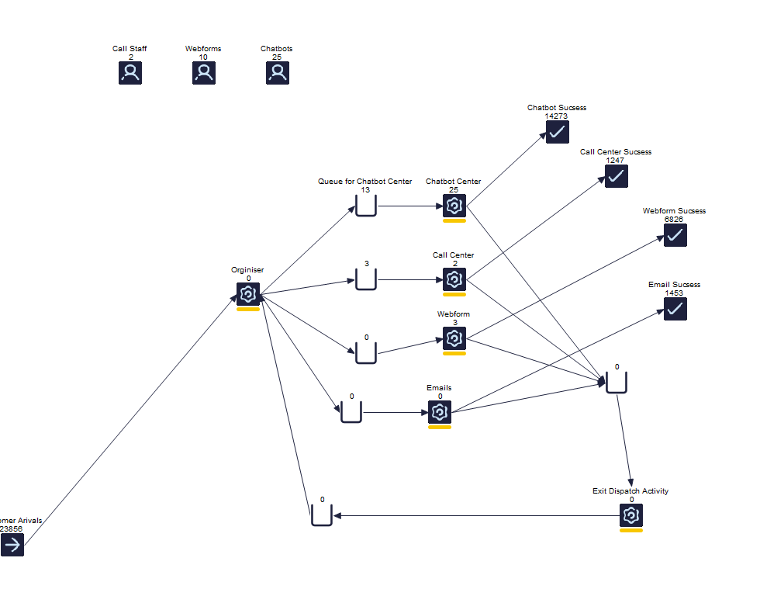
This model improves the CEO’s proposed system by distributing consumers from the organiser across all four channels: chatbot (60%), webform (27%), email (7%), and call centre (6%). The model decides if the customer's query has been resolved, where if unresolved, the customer is routed back to the organiser. This design is intended to prevent bottlenecks and increase total customer completions per week.

Appendix 1.2
CEO’s 1st Model
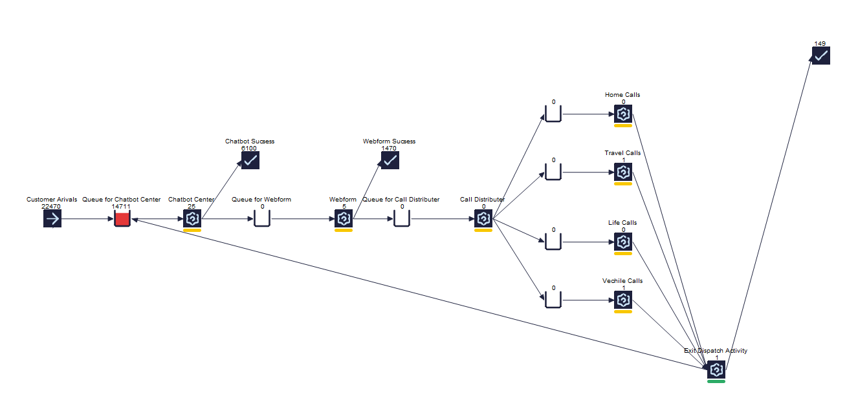

This diagram shows the simulation model based on the CEO’s ideas, which distribute consumers through the channels: chatbot centre, webform and the 4 call centre branches. The call centre branches then decides whether the customer's query has been resolved; if not, the consumer is returned to the exit dispatch activity and sent back to the chatbot queue to reattempt fixing their problem.
Appendix 1.3
CEO’s 2nd Model
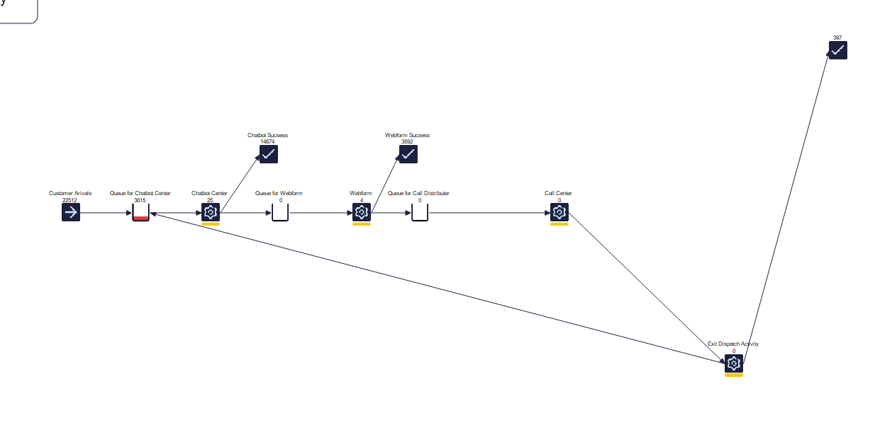
This diagram shows the simulation model based on the CEO’s 24-hour idea, which distribute consumers through the channels: chatbot centre, webform and call centre. The call centre then decides whether the customer's query has been resolved; if not, the consumer is returned to the exit dispatch activity and sent back to the chatbot queue to reattempt fixing their problem. This design is intended to streamline operations and integrate the AI-assisted call service.

Appendix 2.1
My Models KPIs
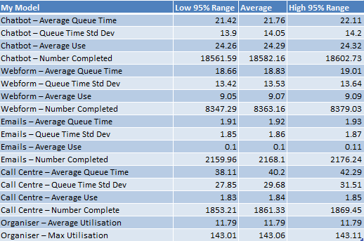
Appendix 2.2
CEO’s Model 1 KPIs
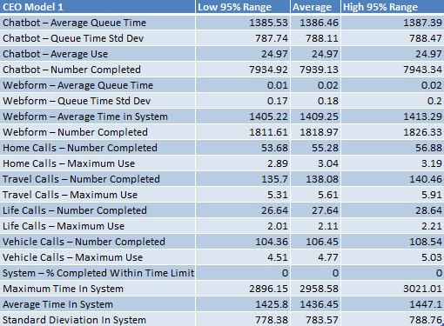
Appendix 2.3
CEO’s Model 2 KPIs
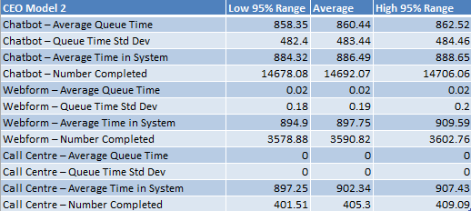
Appendix 3.1
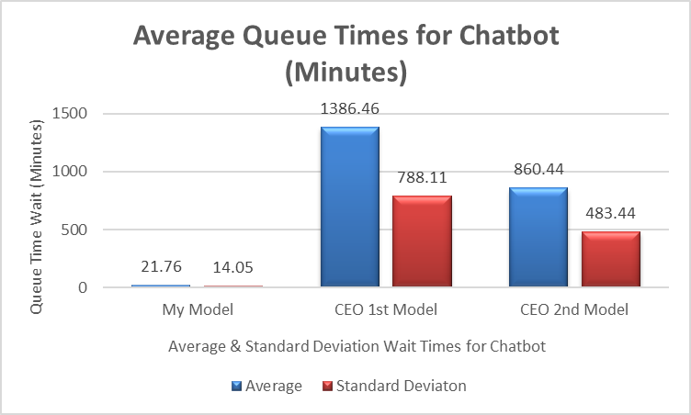
Appendix 3.2
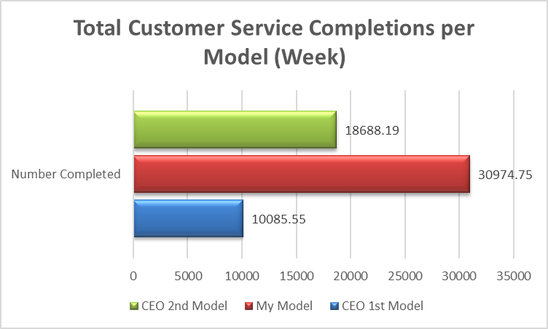
Appendix 3.3
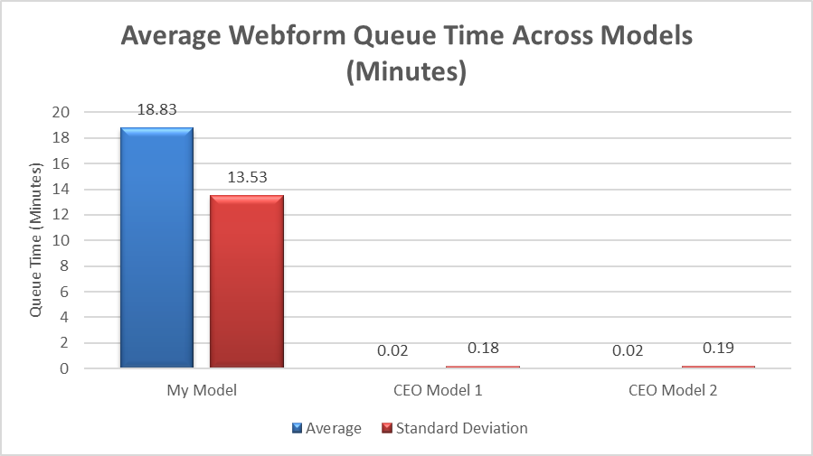
Appendix 4.1
Distribution of satisfaction scores used to classify query resolution.
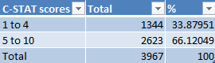
Appendix 4.2
Table of Distribution Percentages from Webform to Call Centre in CEO model 1.
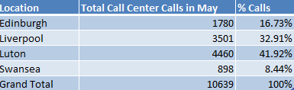
Appendix 4.3
Customer satisfaction scores for Harbour emails in May 2025 were used in my model to measure customer query completion.
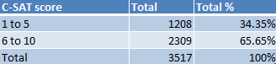
Appendix 4.4
Table showing if anyone's name appears more than once on the Harbour May 2025 spreadsheet.
